The Rev. John Sampson, Pastor
Glen Ridge Congregational Church

The Waters of the New Creation
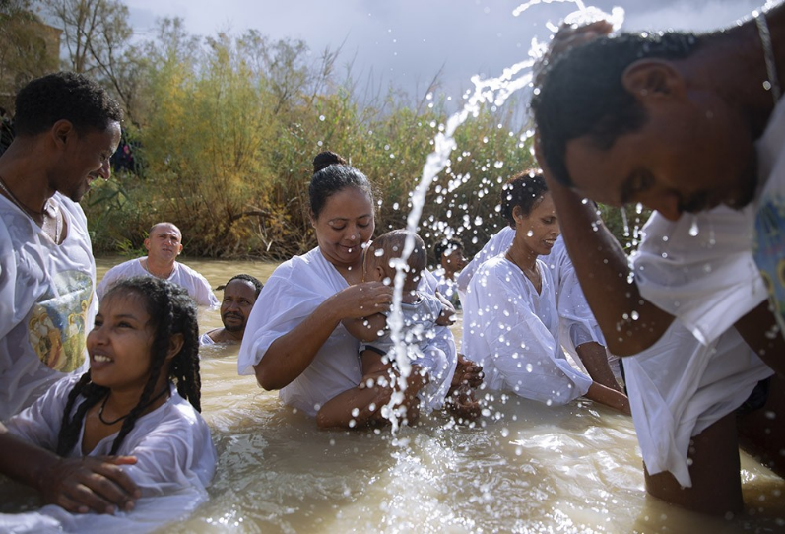

Sunday, January 11, 2026
Matthew 3:13 - 17

Will you pray with me?

God, may the words of my mouth and meditations of all of our hearts be acceptable to you, our rock and our redeemer.

Amen.

We have just come out of one of the most joyful moments of the church year, Christmas time, in which we celebrate the birth of Jesus the Christ. We have some remnants of our celebration, some poinsettias which are on their last legs, and you're welcome to take some home if you would like to nurse them back to health.

During our Christmas festivities, I'm not sure if we did sing it, but there is a song we often sing, “What Child Is This?”. We see Jesus in Christmas time. We see him in the manger. We see him adored. We hear about him. But he doesn't do much to tell us who he is.

The season we are moving into, Epiphany, the season of the breaking-in of Christ's light, is the season when we begin to understand who this child is. Today, years have gone by since we saw Jesus last. He shows up unexpectedly on the banks of the Jordan River, meeting John, and members of the wider Jewish community. John who is baptizing, who is dunking the Jewish people in the river as an act of repentance.

We may come to this story and we may see it through the eyes of our understanding of baptism. A sacrament, a moment of giving of the Holy Spirit, given and offered to all of us. But like the kids said, maybe we don't remember our baptism because for many of us, it happened when we were very, very young. We might know baptism more by the baptism of our children, or we've attended someone else's child's baptism.

But the baptism that is happening on the banks of the Jordan River in this story is very different from what we have come to know as baptism. There are no white robes and headbands for the kids. Most of the people there probably would have been older. If you come from a Baptist tradition, or another tradition where you were baptized later in life, that's probably more like what was happening here. There are no special candles. There's no special feast at a local restaurant after baptism at the Jordan. It is an act of repentance.

To repent is to choose a different path forward. It is to look at your life and to say, "I am ready to release things about my life. I am ready to release the direction of my life up to this point. I am ready to go in a different direction." And it's so apropos for what is about to happen in Jesus's life. We've seen Jesus in the manger, but we don't know what's happened in the last 30 years of his life. And maybe it doesn't matter because on this day, Jesus says, that he chooses a new path forward - the ministry that God is offering to him - and my life, and the life of this world will be forever changed because of this decision.

As we enter this new year, we make resolutions about what we want this year to be. Maybe we want to lose some weight. Maybe we want to save some money. Maybe we want to go on that trip we've always wanted to go on. But on this day of baptism when Jesus is changing the direction of his life to welcome God's spirit into his life and motivate his ministry, Jesus is choosing something more radical than losing 5 to 10 pounds.

On this day, when we think about Jesus's choice, I ask you in this new year, what act of repentance, what act of change, what new direction putting you deeper into resonance with God's plan for your life and the life of the world will you say yes to?

We often think of repentance as an individual act, of baptism as being an individual act. But I've said it before in the ancient prophets, the idea of sin and brokenness, of a need for repentance was not usually individual. It was usually communal. The prophets came to the people and said, "Hey people, your road has sort of gone off the rails. It's time to reimagine how you will come back into resonance with God's dream for you."

When I think about what has happened over the last couple of weeks in our nation, in our world, I ask this question of repentance to us communally too. Shootings in our streets by our government. Kidnappings in other nations. Threats to take the land of people we have called friend. All done with glee and a sense of entitlement. I wonder this day what act of repentance we, as a people, would embrace. How we would want the rest of this year to unfold differently than how things have unfolded in the past couple of weeks.

Repentance is also not just simply something we say, "Hey, I'm sorry. I won't let that happen again. It's a new me. It's a new year." The repentance that God is looking for, the repentance that is so beautifully modeled in Jesus's ministry, is a path of action. Jesus doesn't just say, "Let your kingdom come." He shows us how to bring that kingdom, that new kind of community that God is inviting all of us to, how it will come to be, what we must do to make that kingdom come. When we think about what we want this new year to be, how we might want to repent to change the direction of our lives. What are the actions that we agree to that we embrace when we think about the world that we want, which may be so different from what the last number of weeks has shown us. What are the actions we will do to bring that world closer to reality?

I think if we embrace a new future and a new pathway, not just with our words, but with our actions, we may, within our hearts, hear God speaking to us just as God spoke to Jesus as Jesus was baptized and began his ministry. We may hear the words, "Look, these are my beloved children with whom I am well pleased."

Amen.

