The Rev. John Sampson, Pastor
Glen Ridge Congregational Church

My Salvation Shall Reach Even to Montgomery
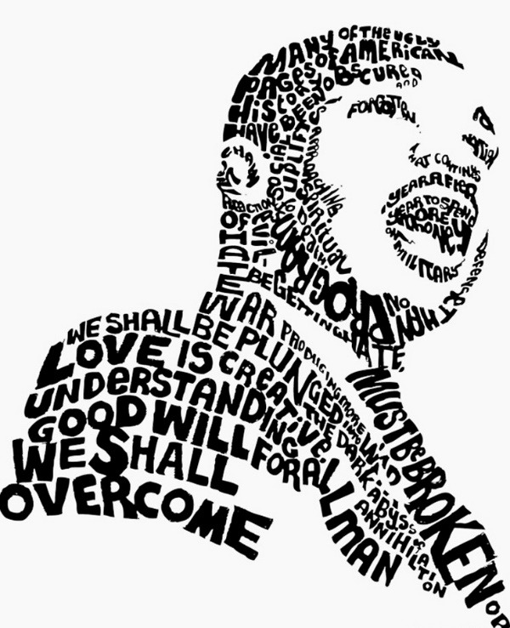

Sunday, January 18, 2025
Isaiah 49:1 – 7

Will you pray with me?

God, may the words of my mouth and meditations of all of our hearts be acceptable to you, our rock, to our redeemer.

Amen.

Today we join with churches around this nation, with organizations and peoples across our country, to hold up and celebrate the life and the work of the Reverend Dr. Martin Luther King Jr., one of the, if not the greatest example and leader of the civil rights movement here in these United States of America. We celebrate his tireless work to bring equality and justice to our African-American brothers and sisters. We hold up and celebrate his tireless work to open the eyes and the hearts of white America, his challenge to us to let go of the places within ourselves where inequality, prejudice, and racism still have a hold on us.

I grew up in a time after Martin Luther King Jr. had been assassinated. I always knew him as the canonized saint of the civil rights movement. The echoes of the words of his “I Have a Dream” speech were things that were just in the ether. They were always there for me. But for some of us, we grew up in a time when these things were new. His work was new. Perhaps for some of us it made us uncomfortable. Perhaps for some of us it made us hopeful and brought joy to our lives.

I think even for those of us who grew up with Martin Luther King Jr. being alive and active in this nation, we still might not have known that much about him. I think many of you know that our Wednesday night book group is reading Martin Luther King Jr.'s first book called Stride Toward Freedom, which is his record of the Montgomery bus boycott. When we were talking in the group about what book we would read next, I asked if anyone had read that book. No, they said, no one had read that book. And some people said they didn't actually know that much about him. Their lives were focused in other ways during his ministry to our nation. So, to go back and engage with a book like Stride Toward Freedom is to rediscover for ourselves who this great man was, and continues to be, for us.

In 1954, before MLK had even finished his doctorate degree at Boston University, he gets a call from Dexter Avenue Baptist Church in Montgomery, Alabama. They want him to be their pastor. And he and his wife Coretta think about this offer. They pray about this offer because it is going to mean a drastic change for them. They're going to go from the desegregated, although not unracist, North down into deep Jim Crow Montgomery, Alabama. A city where only one-third of the African American residents have flush toilets. A city in which the voting system is constructed to deny people's ability to even register to vote, never mind actually vote. It is a city in which the African American population is financially disadvantaged by orders of magnitude from their white neighbors. It is into this place that Dexter Avenue Baptist Church calls him. It is into this place that God calls him to do his ministry.

Montgomery at that time was defined by all of the marks of Jim Crow: the segregation, the inequality in all aspects of life. One of those aspects was the busing system in Montgomery at that time. You would pay your fare. Everybody paid the same fare. And if you were white, you sat at the front of the bus. And if you were African American, you had to sit at the back of the bus. If you were African American and you were sitting at the back of the bus and a white person came in and there was no other seat, you had to stand up and offer your seat to that person and stand for the rest of the trip. When Martin Luther King Jr. arrives in Montgomery, something happens soon after he gets there. A young girl, 15 years old, named Claudette Coven, who you might have seen died this past week, gets on the bus and at some point she is asked to stand and move so that a white person can take her seat. And she refuses. She is pulled off of that bus, arrested, brought into a cop car, and she says she feared for her life because she knew, as many of our African brothers and sisters still know, that interactions with the police can be the last thing you ever experience. She was not harmed. She was let go.

MLK, and other community leaders, met with the police chief and other white leaders of the community and they say, "We're never going to do this again. It's so bad." And nothing happens. It's just a few months after that that Rosa Parks does the same thing. She gets on a bus and she refuses to move and she is arrested. And that is the spark that lights the tinderbox of Montgomery. That is the spark that motivates MLK and other leaders in that city to implement a boycott of the busing system.

At first, they were only going to do it for one day. They had asked all of the African-American citizens of that city to stop riding the bus for one day. And on that first day, 50,000 African-Americans did not ride the bus. Through a peaceful, nonviolent form of protest, they stood up against the injustice of Jim Crow. And then they did it another day. And they did it another day. They boycotted the bus system for 381 days. And in that time, people walked, they carpooled, they rode their bikes in whatever weather was there; on a snowy day like this, if it ever snows in Montgomery, Alabama. And finally, they won. Their boycott, their peaceful resistance was successful. It was the largest nonviolent peaceful resistance movement this nation had ever known at that time and the buses were integrated.

This led to a cascading effect of other bus systems being integrated and other forms of engagement in the civil rights movement. This is the first thing that MLK does in his illustrious career, in his challenging witness to the evils that lived and continue to live in the American heart.

We heard today the ancient prophet Isaiah writing 2,500 years ago about a servant of God. When I read this passage, I thought immediately of MLK. The prophet says, "You knew me before I was even born." I think God knew MLK before he was even born. I think God knew MLK and called him in 1619 when the first 20 Africans were enslaved on the shores of Comfort Point in Virginia. I think God was already calling MLK at that point to liberate a people who would be enslaved, so many years later.

The prophet says that God gave him a sharp tongue, a tongue like a sword. And if we know anything, as the kids said, he knew how MLK used his tongue in his sermons, in his speeches, in his writings. MLK changed his African-American brothers and sisters, leading them to believe in their innate sacredness, a gift from God that no human could take and made white America face up in the mirror to itself and remember our pledge that this nation was supposed to be one nation under God, indivisible, with liberty and justice for all. Not just if you were white, not just if you were rich, not just if you were elite or empowered, but for all Americans.

The prophet talks about days in which he felt weary. The hymn we just sang was Martin Luther King Jr.'s favorite hymn. And it talks about the weariness of what it means to be a prophet. And the way that God comes in even at our darkest moments to uphold us and
encourage us to give us the strength to go another day.

When we think about the civil rights movement we think about the names Martin Luther King Jr., Claudet Colvin, John Lewis, Rosa Parks, and others. But there is another name of another actor in this story whose name sits in the background and that name is God. MLK always thought that God was moving through the civil rights movement. I agree with him because where there is a call for justice and equality, the recognition of the sacredness of the other, engaging with the other, not to dehumanize them, but to recognize their common humanity and to reach out in love, I think those are the hallmarks of where we can see God's spirit moving among us.

So, on this day when we think about MLK and we remember his legacy to us, we remember a story of hope. For many of us, this is a dark time in which various powers in the world seem too powerful; seem like things could not change; they could only be worse; that we must accept the world that we live in.

We have only to remember the story of MLK and of the civil rights movement. To be able to believe again that God will not let stand injustice and evil and separation, but that God truly is calling us all across space and time to be one family, one people, indivisible, and embraced by God's love. Amen.

