The Rev. John Sampson, Pastor
Glen Ridge Congregational Church

The Peaceable Kingdom
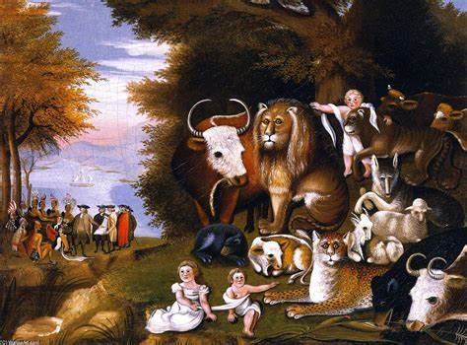

Sunday, December 7, 2025
Isaiah 1:1 - 10

Will you pray with me?

God, may the words of my mouth and the meditations of all of our hearts be acceptable to you, our rock and our redeemer.

Amen.

I've been sick for two weeks. I have a bad cold that never seems to want to let go of me. And maybe you're like me. When you get sick, you watch a lot of TV. You've got your A-list of the series and the shows and the movies you've really been wanting to watch. You've got your B list of shows you probably wouldn't mind watching, but they're not like at the top of the list. Then you've got your C list, which I watch when I have nothing else to do.

And when the C list is gone through, you've got Tik Tok. Tik Tok, that platform on which people are posting very short videos of all kinds of things. I've been sick for so long, I'm not just in Tik Tok. I'm on the Board of Directors of Tik Tok. So, if you go into Tik Tok, you can search for videos that you want to see, but it also makes all these suggestions.

And so, there I was in suggestion land on Tik Tok, and I get this little video, and it's of a Rottweiler running down a snowy road. And out from the side runs a fully adult black panther. It races towards the Rottweiler. It jumps and leaps with its claws out. And I was like, that Rottweiler is today's cat chow. But instead of attacking the dog, it hugs the dog. And they roll together in the snow and they play with each other.

There are so many things about that video that were surprising to me. So surprising that I had to look to see if there were any of those markers that show you if it's AI. Not AI. For some reason, a young couple has adopted a black panther. I don't even know where you go to get a black panther, but they have a black panther. And the black panther's name is Luna. The dog's name is Venza. And they're growing up in this house together. And everybody's still got all their fingers.

When I say I looked to see if this was AI, what I'm really saying is that I couldn't believe it was true. I couldn't believe that a dog, a domesticated dog and a black panther would be friends, would grow up together, would share a house together, would snuggle on the couch together. If you watch other Tik Toks by those same people, you'll see that. And yet, here it is.

When the ancient Christians tried to tell us what Jesus's coming would be like, it's as if they went back to their old ancient version of Tik Tok. They went to the prophet Isaiah and they found a story in Isaiah that said the coming of the Christ would be as if these animals who we think of as being mortal enemies, vicious to one another, harmful to one another, and to us, would no longer be in conflict with each other, but would be friendly with one another, would play with one another, would sleep together, eat out of the same bowl, snooze on the couch together.

In this season of Advent, as we come closer and closer to Christmas, to the birth of Jesus, the one we will call the Christ, we ask ourselves, what will the coming of Christ look like? And our tradition, our spiritual ancestors tell us it will be something like all of the animals living together in a peaceable kingdom. It will be like humanity and the creation being reconciled.

You may have seen on the cover of your bulletin there's a painting there by Edward Hicks. A 18th and 19th century painter, and American Quaker, was painting in Pennsylvania and he did a whole series of these paintings he called the peaceable kingdom. And what might strike you at first when you look at that painting is that it tells this story of Isaiah. It shows you all of the animals reconciled amongst themselves led by a child, led by the one we call the Christ.

But if you look to the left and in the background, you'll see another scene, small, easy to overlook. It is the scene of a group of Native Americans and Quaker settlers. And someone has a big scroll and they're talking about this scroll. It is their peace treaty.

The coming of the Christ doesn't just promise to us a reconciling of animals and of humanity with the animal realm. It promises to us if we would allow the Christ to be born among us and within us that our animality would be healed and that we too could be true humanity living in peace with one another. Even if we are dealing with our brothers and our sisters who may seem so different from us, so alien to us. It promises, in this way, that what is coming to birth will be a way of peace. A peace that we can't even imagine. A peace that we need to look to see if it is stamped with an AI stamp because it seems impossible. And yet we, as the people of Christ, believe that just like Luna and Venza can be friends in Christ's light and in Christ's presence, in Christ's birth, we too may be friends with each other.

Amen.

