In Heaven as It Is on Earth
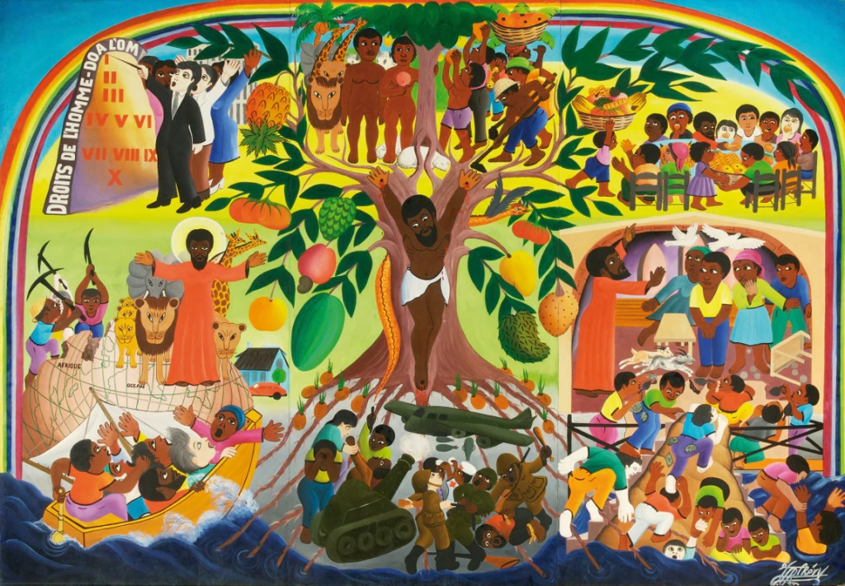
“The Tree of Life”, Jacques-Richard Chery, 1982.
Glen Ridge Congregational Church
The Rev. John Sampson, Pastor
Scripture: Luke 9:51 – 62
June 29, 2025

Will you pray with me?
God, may the words of my mouth, and the meditations of all of our hearts, be acceptable to you, our rock, and our redeemer.
Amen.
Today is the final Sunday of Pride month, the final day of celebrating the experiences of LGBTQI+ people across this nation. And as an Open and Affirming congregation we also celebrate the welcoming of LGBTQI+ people into the full life of our congregation. In this moment we hear a story from the Gospel of Luke, which may not seem to have anything to do with Pride, but as I read this passage over and over earlier this week I couldn’t get away from the feeling that it was a Christian commentary on the earlier story of Sodom and Gomorrah shared in the book of Genesis. It is a story that has been used over centuries to desecrate the lives of LGBTQI+ people. It is a story that we need to reimagine as an act of the church’s repentance for all it has done to sexual and gender minorities over the years.

So, let me retell the story of Sodom and Gomorrah quickly. It goes like this. God hears of the great sin of the cities of Sodom and Gomorrah, although the sin is never actually stated. Whatever it is, it is so great that God decides to destroy the cities with a rain of fire and brimstone. But God sends God’s angels, God’s messengers, to the city to save a man named Lot, and his family. The angels appear one day, and they receive a less than warm welcome. The only person who shows them any kind of hospitality is Lot, who invites them to stay overnight at his house. He doesn’t know who they are, but he does know the tradition of showing strangers compassion and hospitality. They come, and sometime during the night the men of the town show up at Lot’s door, and they demand he send them out so they can “know” them. In this case “know” is a euphemism for sexual intercourse. Lot refuses, although he does offer his daughters instead. The angels blind the townsmen and then tell Lot of God’s plan to destroy the cities. Lot takes his family, and as they are fleeing, they can hear behind them the sounds of the cities being consumed by fire. No one looks back, except Lot’s wife, who is turned into a pillar of salt.

Not one of the Bible’s happier stories.
For a long time, many Bible theologians and commentators have taught that the sin of Sodom and Gomorrah was the sin of homosexuality, because of the townsmen’s demand to “know” the strangers, to have sex with God’s angels. But a more traditional understanding of the sin of Sodom and Gomorrah was that it was the sin of inhospitality, of not welcoming the stranger, of doing violence to those who are unfamiliar. That Sodom and Gomorrah’s sin didn’t have anything to do with sex, and the relationships between same-sex partners.
Fast forward to today’s story of Jesus and his disciples traveling to the unnamed town in Samaria and there are so many echoes of the earlier story from Genesis. There are strangers entering an unfamiliar town. There are messengers sent from a divine figure. There is inhospitality, a rejection of the stranger. There is a call to punishment for this sin by raining down fire from the sky to consume the town.
But there is a very different outcome in Luke.
Where the destruction of Sodom and Gomorrah has been celebrated throughout the centuries by many anti-LGBTQI+ commentators, Jesus responds by rebuking the very idea. Jesus doesn’t deny that the Samarian town was inhospitable to him and his disciples. But he does reject the idea that it should be punished and destroyed for its hard-heartedness.
Two similar experiences. Two very different outcomes.
Have you ever found yourself in a situation where you felt unwelcome? Where you were not received with kindness and grace because you were new, or unfamiliar? I think we all have. And how did that make you feel? Perhaps hurt. Perhaps frustrated. Perhaps even a little angry. To feel unwelcome can arise negative feelings and thoughts within us, and it might even surface desires in our hearts and minds that call for some kind of response or retribution. And it is into these very moments that Jesus arrives, uninvited, perhaps a stranger to the situation, and short circuits our seemingly justified feelings for a response on our part.
Jesus arrives and asks us to break the economy of retribution, to disassemble the inertia of brokenness that we might even feel is justice itself. Instead, he calls us not to respond, but to move on. Because at the root of it, I think he calls us to remember his commandment to love our neighbors as ourselves, even when they harm us. Even when they cannot welcome us as friends and neighbors. That’s not to say that we should simply put up with the hurtful actions of those around us. Jesus and his disciples don’t stay in the Samarian town to be abused. They make the decision to move on, and to put those people behind them.
And in doing so, Jesus puts behind him the actions and motivations that have traditionally been attributed to God. Was God right to destroy Sodom and Gomorrah? Or would Jesus have rebuked God, the one he called Father? Is it OK for nations and the church to desecrate LGBTQI+ people? Or would Jesus have rebuked them/us by exposing this kind of behavior as flawed biblical reflection? Is it OK for a nation to vilify the stranger and the foreigner? Or would Jesus ask us to break with an idea of justice that allows for the abuse and inhospitality of those who are alien to us?
And in all of these questions might not Jesus be asking us to look honestly and courageously into the motivations of our own hearts, and instead of projecting the negative things we might find there onto God, might he not be asking us to replace them with love?
I think that the ways in which we grapple with these questions, the way we let these questions transform us, free us from a kind of inner paralysis, that can feel like we have been turned into a pillar of salt. They free us to continue along the path of salvation, not of the next world, but even of this world. Even of our lives, here and now.

Amen.

